**Eudaimonia v 1.0**

**Getting Started:**

Eudaimonia is a productivity tool for all versions of Windows, that allows you to block both websites and programs.

To get started simply download the Eudaimonia folder, and locate Eudaimonia.exe. The application is 100% GUI-based and all pages can be accessed from Eudaimonia.exe.

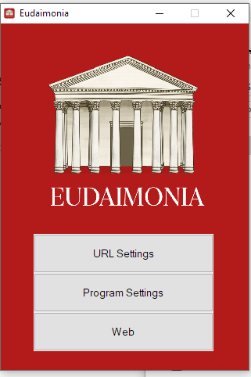

Note: You may get a warning to allow administrator access upon starting it. Click “Yes” as this is an internal program that runs in the background that is necessary for the program to function properly.

**URL & Program Settings:**

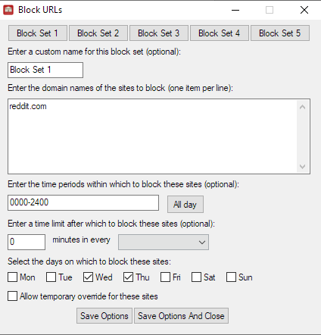

Both the URL and Program blocker offer up to 5 block sets with unique rules and unique names. The fields are dynamically saved (e.g. just typing in them saves them automatically) although you can also manually save them with the two buttons below.

Some features of the settings:

**Enter the time periods:** You can use 24 hour time format, e.g. 1200-2400 to block programs or URLs for a certain time period (e.g. 12 pm-12 am) or all day to block it the entire day. **Note that the program takes 60 seconds to remove/update any blocks**.

**Enter a time limit after which to block these sites:** If you want to be able to browse a website, for say, 5 minutes, every hour, you can use the text field and drop down to specify this.

**Select the days:** This will block the websites/URLs for the entire day on the specified days.

**Allow temporary override:** If you want to temporary bypass the blocker for 15 minutes, you can tick the checkbox and type in the 32-bit code. This will turn off the blocker and allow you to access anything you blocked.

The URL and Program blocker run automatically in the background and they will update themselves on which URLs/programs they are blocking every 60 seconds.

**Closing the program:** We did not want to make it easy for people to bypass these blocks, so there are two ways to turn off the blockers. One way is to go into task manager and kill URLBlocker.exe and ProgramBlocker.exe. The other way is a temporary override. More features will be added to this after the Hackathon.

**Potential Troubleshooting:**

The URLBlocker uses Windows’ functionality to block websites. In case the blocks are not removed (this has not happened on the 5 computers we tested, although could happen due to user error, e.g. a certain setting enabled in say block set 3), you can go to C:\Windows\System32\drivers\etc and find a file called hosts. Right click this file and open it in notepad. You will see the blocks that Eudaimonia placed here. You can simply just delete the entries if Eudaimonia has not automatically removed them.

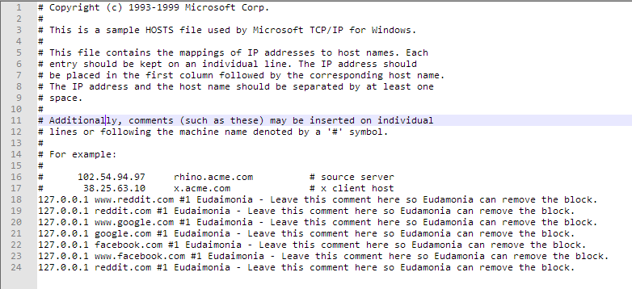

The URL Blocker works for any browser. Major browsers have internal caches that override this implementation but testing it on a less frequently used browser, e.g. Edge if you use Chrome or Firefox, will see sites blocked immediately and major browsers will be blocked within 5-15 minutes. Typing [www.reddit.com](http://www.reddit.com) or [www.google.com](http://www.google.com) will also yield better results

Example of URL Blocker functionality:

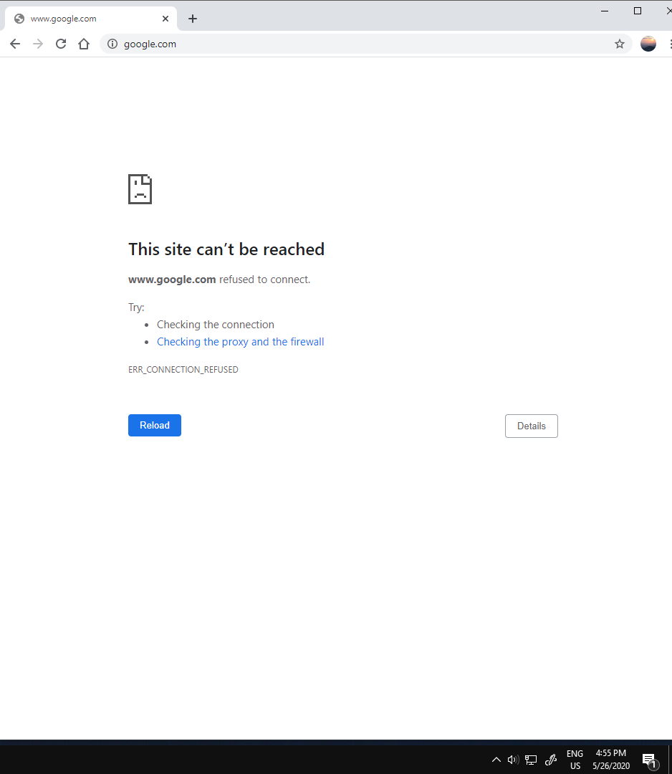

You can see in the image that I typed google.com but Chrome parsed this into [www.google.com](http://www.google.com). I will be adding a feature that automatically does this in later versions of Eudaimonia. Also notice that my internet is not disconnected and yet the URL can’t be reached.